**Different failure rate with antenna**

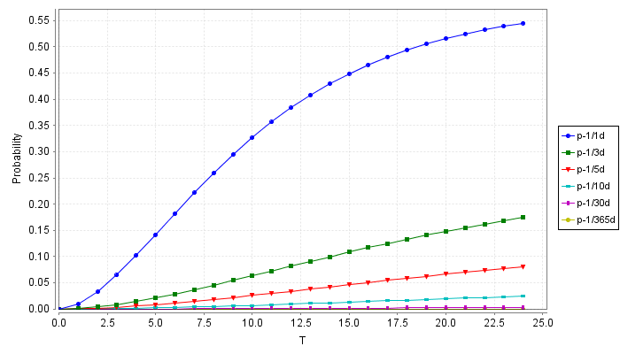

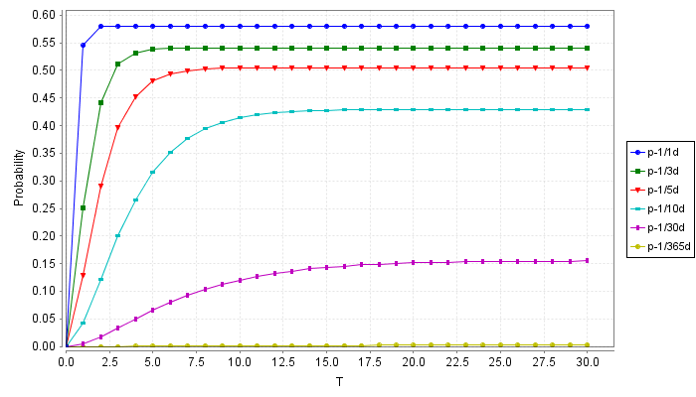

Fig. 3. The performance of indoor positioning system with reprogramming function in 24 hours and 30 days with different failure rate of antenna from once a day to once a year.

Antenna is also a significant component of the whole system that system reliability is also related to the dependability of antenna.

***Finding.*** Figure 3 demonstrates that lower failure rate of the antenna could improve the reliability of the whole system in both the short-term experiment and long-term experiment if combining the two graphs.

***Finding.*** In the first graph in Figure 3, when the failure rate of antenna is greater than 1/30 days, its influence on the reliability of the whole system becomes slight.

Finding. After 15 days, the probabilities of the systems of all the curves become steady.